

Table of contents

**Table of contents** - 1 -

A. **Before you start** - 1 -

1. Gcode preparation: - 1 -

**2.** **Materials** - 6 -

a. PCB board: - 6 -

b. Painting: - 6 -

c. Wooden Socket: - 7 -

3. Focus setup - 8 -

B. **Single Circuit Marking** - 12 -

1. Material mounting - 12 -

**2.** **Code input and control:** - 17 -

a. Gcode: speeds - 17 -

**b.** **Gcode: hatching distance** - 19 -

c. Luban: laser power, fan, run boundary and door detection - 20 -

d. Material thickness and Start - 21 -

**3.** **Marking** - 23 -

4. Job End - 24 -

C. **Multiple Circuit Marking** - 25 -

1. Gcode nesting - 25 -

2. Material mounting - 26 -

3. Code input and control - 26 -

4. Marking - 26 -

5. Job End - 26 -

Troubleshooting - 27 -

Luban Version 4.1.3

# **Before you start**

## Gcode preparation:

|  |  |  |
| --- | --- | --- |
|  | 1 | If you open Luban for the first time, make sure you have selected the right machine (*Snapmaker 2.0 A250*) |
|  |  |  |
|  |  |  |
|  | 2 | Go to “*Get Started*” section of Luban, and select “*Laser*” |
|  |  |  |
|  |  |  |
|  | 3 | Select “*3-axis*” in the laser menu |
|  |  |  |
|  |  |  |
|  |  |  |
|  |  |  |
|  | 4 | Make sure that the settings of the design space are the same as those shown in the figure |
|  |  |  |
|  |  |  |
|  |  |  |
|  | 5 | Click this button |
|  |  |  |
|  |  |  |
|  | 6 | Now select the DFX file you want to import in Luban. |
|  |  |  |
|  |  |  |
|  |  |  |
|  |  |  |
|  |  |  |
|  |  |  |
|  |  |  |
|  |  |  |
|  | 7 | Click this button |
|  |  |  |
|  |  |  |
|  | 8 | Now add the text. Select font, dimension and position  **Don’t change size of the circuit!** |
|  |  |  |
|  |  |  |
|  | 9 | Select the text box and the circuit. Select “*Process*” and then “*Create Toolpath*” |
|  |  |  |
|  |  |  |
|  |  |  |
|  |  |  |
|  |  |  |
|  |  |  |
|  |  |  |
|  |  |  |
|  | 10 | **Jog Speed** should be as high as possible while numerical values of **Work Speed**, **Number of Passes**, **Z Step** and **Laser Power** come from Matlab simulations  **Method must be “On the Path”!** |
|  |  |  |
|  |  |  |
|  | 11 | Select “*Generate G-Code and Preview*” |
|  |  |  |
|  |  |  |
|  | 12 | In the Preview window you can see the final result. If it is correct select “*export*” and then “*Export G-Code to file*” to save the the final G-Code. |

## **Materials**

### PCB board:

The boards have the following characteristics:

* Core material: FR4
* Single or dual sided copper clad
* 100 x 70 x 1.5 mm

### Painting:

The following colors are allowed:

1. Black
2. White
3. Red
4. Blue

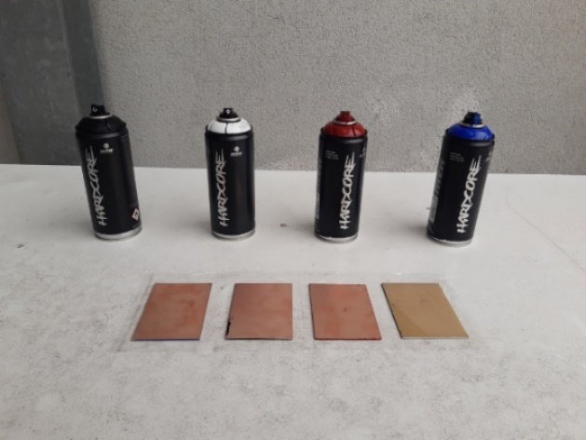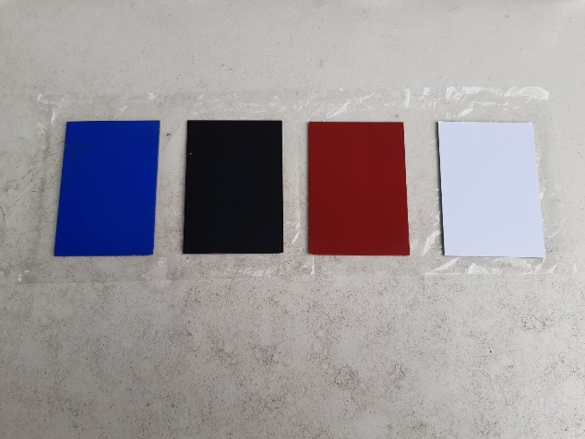

**Tip**: Avoid using an oil-based paint as it will make the laser stripping process worse.

During the painting job, we suggest to:

* Clean the copper surface before painting
* Make sure to distribute paint equally
* Avoid touching board surface with hands if the paint is not dry
* Let the board dry for at least 2 hours before machining

|  |  |
| --- | --- |
|  |  |
| **NO** | **YES** | |

### Wooden Socket:

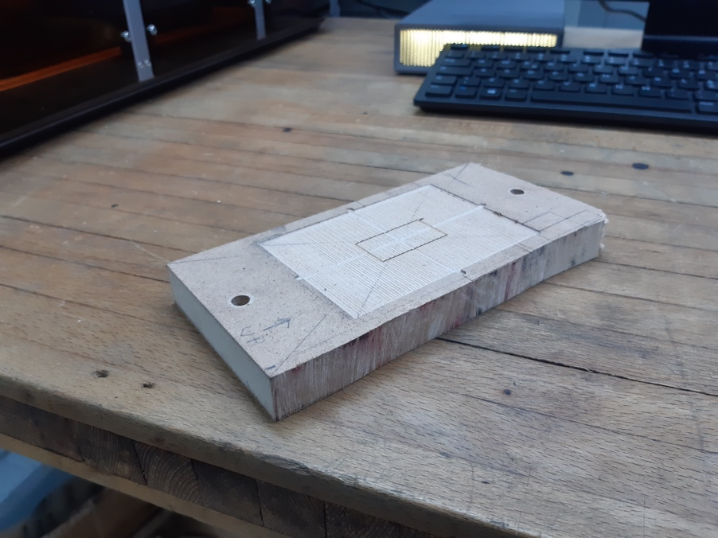

The use of the socket is not strictly necessary but facilitates the carrying out of multiple operations. Its use will be described in detail in the paragraph “Material mounting”.

## Focus setup

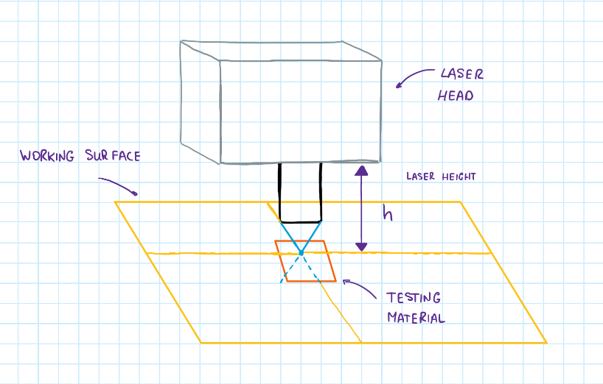Focal point is the point where laser concentration reaches its maximum. It is calculated from the testing material surface (see the picture). We should set it properly to take the most out of laser power. We’ll explain how to set the laser height *H* in the following paragraphs

|  |  |  |
| --- | --- | --- |
|  | 1 | Follow the Snapmaker Quick Start Guide in order to mount the laser head, **with the wooden working area** |
|  |  |  |
|  |  |  |
|  | 2 | Turn on the machine, and enter the “*Settings*” menu |
|  |  |  |
|  |  |  |
|  | 3 | Select “*Laser*” menu |
|  |  |  |
|  |  |  |
|  | 4 | Make sure the auto focus is off |
|  |  |  |
|  |  |  |
|  | 5 | Follow the Snapmaker Quick Start Guide in order to set the laser focus manually |
|  |  |  |
|  |  |  |
|  | 6 | In the same menu of point 3, select “*Adjust Laser Height*” |
|  |  |  |
|  |  |  |
|  | 7 | In this window you can see the value of the effective laser height.  If you already know it you can set it without doing the procedure explained before |

# **B. Single Circuit Marking**

The following section describes the procedure to laser engrave a single circuit in the center of a board.

## Material mounting

|  |  |  |
| --- | --- | --- |
|  | 1 | Follow the Snapmaker Quick Start Guide in order to mount the laser head, with the wooden working area |
|  |  |  |
|  |  |  |
|  | Logo, icon  Description automatically generated  2 | Fix the Wooden Socket to the working surface, using two M4x30 screws. Make sure the UP arrow pointing outwards form you  **If you use screws longer than 30 mm, make sure that the working area and the laser head move without hitting the screws** |
|  | 3 | Open Luban, and select “*Workspace*” |
|  |  |  |
|  |  |  |
|  | 4 | Select “*Wi-Fi*” as connection method |
|  |  |  |
|  |  |  |
|  | Logo, icon  Description automatically generated  5 | Click the refresh button and than “connect” to Idra.4.0  **The printer and the PC with Luban must be connected to the same network** |
|  |  |  |
|  |  |  |
|  | 6 | Set the power laser to 5%, and click its refresh button. Than set the “Laser Power” on.  **Make sure the door detection is on**. |
|  | 7 | Using the navigation controls match the laser point with the diagonals’  intersections  After that set the “Laser Power” flag off |
|  |  |  |
|  |  |  |
|  | 8 | Create the macro to save the coordinates just found.  Click the “+” button, and copy the G53 and G0 commands with the X and Y coordinates.  Run this macro, click "set work origin", and then click "go to work origin". Do this every time you run boundary or launch the marking process. |
|  |  |  |
|  | 9 | Insert the board inside the socket. Make sure that the top side edge of the board touches the top side edge of the socket |

## **Code input and control:**

After we have exported our gcode it is time to make final check before launching the process.

### Gcode: speeds

|  |  |
| --- | --- |
|  | Click on the exported gcode with the right button of the mouse and chose “Open with”. |
|  | Select Notepad or any other text editor that you usually use |
|  | Now you should see the set of instructions that machine is going to execute.  You can see how much time (in seconds) marking take in” estimated_time(s)” row.  You can see the **work_speed** (speed of the laser head while it strips) and **jog_speed** (speed while it is not stripping).  Don`t pay attention on the power row since it will be overwritten inside luban |

Scroll down until appears the first row without semicolon.

1. **Jog Speed & Work Speed**

Make sure Jog Speed & Work Speed are correct and if not, you have two options

* **Safe Option:** Create new gcode from the start (from .dwg file)
* **Risky Option:** Manually rewriting those commands for each pass of your circuit

Click Ctrl + F and type in “Header Start”, choose Direction: Down and click “Find Next”

This way you will iterate through each pass of your circuit and you should pay attention to correct G0 F (Jog Speed) and G1 F ( Work Speed ) in each pass.

Just manually change the number inside the row

### **Gcode: hatching distance**

Find the first row without semicolon; and look at the code after it

Find some two consecutive rows (starting either with G0 or G1) and decreasing Y coordinates.

The difference between Y coordinates is hatching distance

In our example H = 17.89mm - 17.74mm = 0.15mm

Make sure Hatching distance is correct and if not, you have only 1 option:

**Control hatching of your .dxf file in Autocad and create new gcode from the start**

### Luban: laser power, fan, run boundary and door detection

|  |  |
| --- | --- |
|  | Click + G-code files and open the gcode that you have prepared ( make sure it has .nc extension ) |
|  | Open prepared gcode. |
|  | Control that LED Strips, Exhaust Fan and Door Detection are always on |
|  | Execute macro that you created in step B.3 then click Set Work Origin and then click “Run boundary” to verify where your circuit will be printed |

### Material thickness and Start

|  |  |
| --- | --- |
|  | Material Thickness should be equal to the height of material that you put on the work surface (in our case it is the height of the wooden socket) |
|  | To set material thickness, click “Start on luban” |
|  | The window will pop up where you will be able to set up material thickness. Don’t forget to choose Auto Mode |
|  | Right after that turn on Laser Power to 100 % and click arrow button |

## **Marking**

|  |  |
| --- | --- |
|  | You can track the engraving progress in the following window |
|  | Make sure to follow the safety rules in place. |

## Job End

|  |  |
| --- | --- |
|  | We recommend cleaning the circuit boards with a cloth, do not apply too much force, do not use liquids such as alcohol or water. Enjoy your circuits 😊 |
|  | Please leave the working space clean. 😊 |

# **C. Multiple Circuit Marking**

The purpose of this section is to illustrate how to laser stripping a board with multiple circuits, joining *n* single files, in a single .nc file containing *n* circuits. To illustrate the procedure, we will refer to the example of joining 4 circuits, but the method can be easily extended to cases where *n* > 4.

## Gcode nesting

|  |  |  |
| --- | --- | --- |
|  | 1 | You can estimate the position of the circuits (purple) relative to board (orange).  You can find the midpoint of each cirucit in the following way.   * C1 (A,B) * C2 (-A,B) * C3 (-A,-B) * C4 (A,-B)   A & B should obatined by trial and error. |
|  |  |  |
|  |  |  |
|  | 2 | Now you can create a new .nc file, with the following structure.    We use the command **G92** to shift the work origin in the center of each circuit before engraving.  After the **G92** command you need to paste all the contents of the file related to the first circuit. Before starting the next circuit, you need to shift the previous origint to the new poistion.  This procedure must be repeted for all the 4 circuits. At the end, save and close the final .nc file. |
|  |  |  |
|  |  |  |
|  | 3 | Now you can import the final .nc file in the workspace preview, and check if all the circuits are in the correct position and fits inside the board perimeter.  If not, return to the point 2, change the A and B values, and check again in the workspace preview if the circuits position are correct.  Repeat this trial and error procedure until the result is correct. |

|  |  |
| --- | --- |
|  | Luban up to version 4.1.3 it is affected by an alleged bug: until the insertion of three circuits the procedure described above works fine. However, starting from the fourth circuit, the position of the centers no longer follows this logic, therefore starting from the fourth circuit it must be determined by trial and error. |

## Material mounting

Same procedure described in paragraph B.1.

## Code input and control

Same procedure described in paragraph B.2.

## Marking

Same procedure described in paragraph B.3.

## Job End

Same procedure described in paragraph B.4.

# **D. Troubleshooting**

|  |  |
| --- | --- |
| Problem | Solutinons |
| Stripping is ineffective | * Reduce hatching distance * Raise Laser Power * Slow your work speed down * Raise number of passes * Check laser focus |
| **Process is too slow** | * Check that the work speed is set to the correct value * Raise jog speed * Raise hatching distance * time of process is quality tradeoff |
| Macro does not work | Make sure there’s no break line between G0 and X Y coordinates |

# If you find any